GiftAid logo

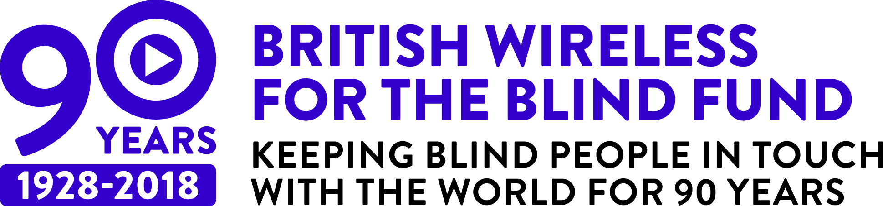

Make your gift worth even more

Thank you again for your kind support. If you would like to make your already wonderful donation go 25% further through allowing us to claim Gift Aid simply sign the below declaration, required by HM Revenue & Customs and return it to us using the enclosed freepost envelope thank you for your generosity.

Using Gift Aid means that for **every pound you give, we get an extra 25 pence** from HM Revenue & Customs. For example, a gift of £10 can be turned into £12.50 and it won’t cost you another penny. Simply return this form and we’ll do the rest.

**I am a UK tax payer and would like to Gift Aid my donation and any donations I make in future or have made in the past four years.**

I understand if I pay less income tax and/or capital gains tax than the amount of Gift Aid claimed on all my donations in that tax year, it is my responsibility to pay any difference. Please notify BWBF if you want to cancel this declaration, change your name or home address, no longer pay sufficient tax on your income and/or capital gains. If you pay income tax at the higher or additional rate and want to receive the additional tax relief due to you, you must include all your Gift Aid donations on your Self-Assessment tax return or ask HM Revenue and Customs to adjust your tax code.

Name…………………………………………………………………………………………

Address………………………………………………………………………………………

………………………………………………………………………………………………

Postcode……………………………………………………………………………………

Email…………………………………………………………………………………………

Telephone……………………………………………………………………………………

Signed……………………………………………………… Date …………………………

In accordance with the data protection act 1998, BWBF will not pass any of your information to any other organisation.

**Registered Charity No.1078287. Scottish Charity No. SC041582.**

**Registered as a Limited Company in England. Company No.3870182**